22-1 VLAN and Inter-VLAN Routing Configuration – Lab Exercise

In this lab you will perform a VLAN configuration for a campus network, including Virtual Trunking Protocol, Access and Trunk ports, and inter-VLAN routing.

Lab Topology
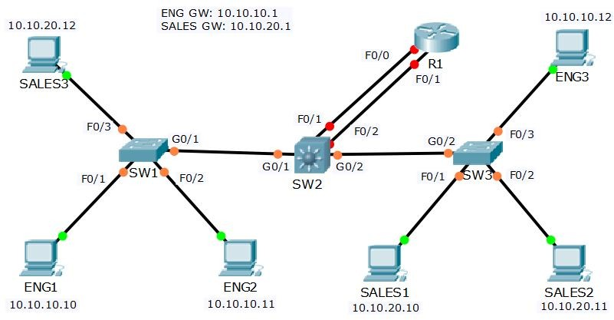

Load the Startup Configurations

Open the ‘22-1 VLAN and Inter-VLAN Routing Configuration.pkt’ file in Packet Tracer to load the lab.

VTP, Access and Trunk Ports

- All routers and switches are in a factory default state. View the VLAN database on SW1 to verify no VLANs have been added.

- View the default switchport status on the link from SW1 to SW2.

- Configure the links between switches as trunks.

- Configure SW1 as a VTP Server in the VTP domain Flackbox.

- SW2 must not synchronise its VLAN database with SW1.

- SW3 must learn VLAN information from SW1. VLANs should not be edited on SW3.

- Add the Eng, Sales and Native VLANs on all switches.

- Verify the VLANs are in the database on each switch.

- Configure the trunk links to use VLAN 199 as the native VLAN for better security.

- Configure the switchports connected to the PCs with the correct VLAN configuration.

- Verify the Eng1 PC has connectivity to Eng3.

- Verify Sales1 has connectivity to Sales3.

Inter-VLAN Routing – Option 1 Separate Interfaces on Router

- Configure interface FastEthernet0/0 on R1 as the default gateway for the Eng PCs.

- Configure interface FastEthernet0/1 on R1 as the default gateway for the Sales PCs.

- Configure SW2 to support inter-VLAN routing using R1 as the default gateway.

- Verify the Eng1 PC has connectivity to the VLAN 20 interface on R1.

- Verify the Eng1 PC has connectivity to Sales1.

- Clean-up: Shut down interface FastEthernet0/1 on R1.

Inter-VLAN Routing – Option 2 Router on a Stick

- Configure sub-interfaces on FastEthernet0/0 on R1 as the default gateway for the Eng and Sales PCs.

- Configure SW2 to support inter-VLAN routing using R1 as the default gateway.

- Verify the Eng1 PC has connectivity to the VLAN 20 interface on R1.

- Verify the Eng1 PC has connectivity to Sales1.

- Clean-up: Shut down interface FastEthernet0/0 on R1.

Inter-VLAN Routing – Option 3 Layer 3 Switch

- Enable layer 3 routing on SW2.

- Configure SVIs on SW2 to support inter-VLAN routing between the Eng and Sales VLANs.

- Verify the Eng1 PC has connectivity to the VLAN 20 interface on SW2.

- Verify the Eng1 PC has connectivity to Sales1.

